Group Assignment

IS 337

September 20, 2023

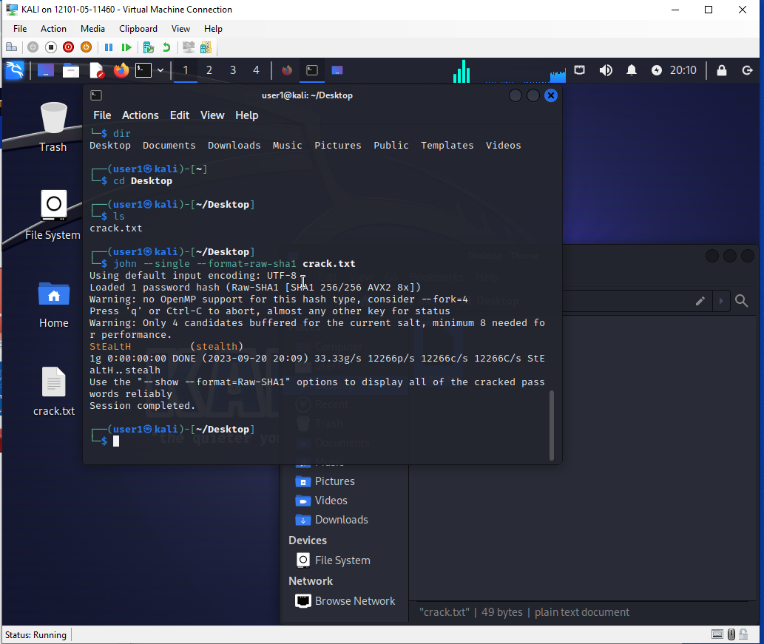

* What was the password for the account your instructor created on your Linux VM?

Our instructor didn’t provide us with a password

* What was the password for the account that your instructor created on your Windows VM?

Our instructor didn’t provide us with a password

* Which of the account passwords took the shortest amount of time to crack, of the accounts that you or one of your team members created?  How long did that password withstand your password cracking attempts?

We were only able to attempt to crack one password with the “Jack the Ripper” utility on the Kali Linux VM. This crack took less than 2 seconds.

* Which of the account passwords, of the accounts that you or one of your team members created, and which you eventually cracked, took the longest amount of time to crack?  How long did that password withstand your password cracking attempts?

We were only able to attempt to crack one password with the “Jack the Ripper” utility on the Kali Linux VM. This crack took less than 2 seconds.

* In what ways could the tools that you used in this Group Project be used for unscrupulous or nefarious ways by network administrators or other IT professionals employed within your organization?

Cracking weak passwords can potentially lead to leaks of confidential material or unauthorized access/alterations of mission critical systems.

* How could the use of these tools be justified in their use in a business environment?

These utilities could be used to test and verify system integrity and the strength of network security.